1st ELGIN SCOUTS
RISK ASSESSMENT FOR RESIDENTIAL VISITS
Group Camp

NAME OF DISTRICT/GROUP: …………………………1st Elgin Scouts ………………………………………………………………………………

NAME OF PERSON COMPLETING RISK ASSESSMENT/UPDATE: ……………Andre Govier………………………………………………………………

DATE OF RISK ASSESSMENT/UPDATE: ……………13/06/2019………………………………………………………………………………………………..

The aim of a generic risk assessment is to provide general information on the type of hazards adults and young members (as well as others who may be involved) are exposed to.
The list given is by no means an exhaustive one. Hazards which are not listed but are specific to your visit should be recorded on the blank assessment form
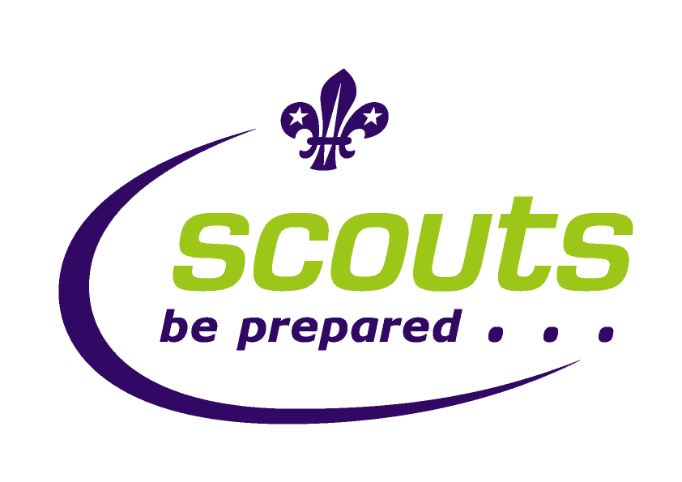

P.O.R rules relating to the Group camp

The only information we need to be aware of and comply with is the information contained in the general factsheets

Scout Led Activities

Activity | P.O.R Rules | Other information | Scouting Authorisation Required | Extra third party insurance required | Notification Required
N/A | - FS129999 safety in Scouting: Safety Checks  - FS120000 Activities – Risk Assessment  - Safety checklist for leaders  - FS120000 Activities - Risk Assessment  - FS120075 - Intouch factsheet  - Purple card  - FS120088 Weather Forecasts in Outdoor Activities  - POR 9.3 and 9.5 | No | No | No | No DC present

Risk assessment
Ratios | 1:12 max for Scouts
Qualifications | - Green field camp clr – Andre, Alan,Ross and Paul  - Terrain 0  - Andre, Steve T, Alan, Ross, Paul all in date medical quals  - Andre and Alan have food hygiene.  - All adults’ disclosure cleared.
Control Measures in force | - Detailed weather forecast to be obtained 3 days prior and on night before  - Well pitched tents (supervised by leaders)  - Careful selection of tent area taking into consideration other users, likelihood of flooding.  - Check of food cooked on fire by leaders – Andre/Alan has food hygiene qual  - Emergency phone – mobiles  - Intouch procedures reviewed – Alan Mobile POC – all scout’s parents contact details to be taken  - First aid kit to be taken  - In the event of an incident requiring one or more emergency services to be summoned the activity will be terminated immediately and the scouts and leaders taken to the hall as quickly as possible.

HAZARD | Risk before control Measure | Who is at risk | STEPS TO CONTROL RISK | RISK LEVEL if controls implemented | REVIEW AND DECISION
Hypothermia | Medium | All on camp | - Ensure all on activity are dressed suitably for the weather on the day  - All on activity to carry or wear waterproof clothing depending on the weather on the day  - Check suitable sleeping bags and carry mat used  - Brief scouts on signs  - If weather worsens – scouts move to hall | Low | No further revision  considered necessary at this time
Getting lost | Medium | All on camp | - Unlikely as scouts limited to grounds of hall and up to 50m into woods  - When away on walk, leaders present with maps  - Every leader to carry mobile phone  - Scout Leaders spaced throughout group (with 1/2 at the end to sweep up if necessary)  - Regular check points | low | No further revision considered necessary at this time
Swimming | Medium | All swimming | - Route planned to pool  - Single file walking  - Leader front middle and rear  - Leader at all crossings  - Brief before walk  - Map and route discussed before walk  - At pool trained life guards  - On permission to camp form details about swimming ability  - As well as leader in pool, one watching | Low | District running all water activities
Dehydration | Medium | All on camp | - All to take suitable water bottle for walk  - Water always available  - Brief scouts on signs of dehydration | low | No further revision considered necessary at this time
Tiredness | Medium | All on camp | - Have leaders look out for struggling scouts  - ‘Down time’ during the camp to allow scouts to rest if necessary | low | No further revision considered necessary at this time
Weather | Medium | All on camp | - If deemed unsuitable by the leaders at any point the camp can be closed early  - Check weather prior to event and during  - If temperature falls below 5 deg at night and 10 degs in days leaders will consider cancelling camp.  - Heavy winds or extreme rain will cancel the camp.  - At any time any leader deems weather unsuitable – scouts will be decamped to hall. | low | No further revision considered necessary at this time
Burns and Scalds | Medium | All on camp | - Scouts taught to correctly light and use fire before using  - Scouts supervised when cooking their own food | Low | No further revision considered necessary at this time
Fire | Medium | All on camp | - Water buckets to be readily available  - All containers of flammable liquids should be marked and stored away from fire/tents  - No cooking in tents – if weather conditions are in appropriate leaders will find alternative cooking areas  - Adequate spacing between tents  - No ball games or running around fires  - Fires only light when leader present and supervising | Low | No further revision considered necessary at this time
Food poisoning | Medium | All on camp | - All food to be checked by leader before eating  - Andre/Alan has food hygiene certificate  - All scouts to wash hands and alcohol gel available  - No cross contamination between cooked and raw food | Low | No further revision considered necessary at this time
Security | Medium | All on camp | - Ground surrounded by fencing and gate  - Leaders to walk around camp through night and check  - Lighting around field  - Leaders in tents in designated area  - Scouts will be told of leaders sleeping arrangements and what to do in an emergency | low | No further revision considered necessary at this time
Injury from penknives | Medium | Scouts and Leaders | - All scouts been trained during Scouts evening on how to use knives appropriately  - Leaders watching over use of knives  - Scouts will be reminded on health and safety during the camp  - Pen knives to be used by Scouts only | low | No further revision considered necessary at this time
Injury from activities | Medium | All on camp | - Leaders will always be present during activities  - Participants will be spoken to regarding expectations when participating in activities  - First-aid kit present (with first-aiders) | Low | No further revision considered necessary at this time

